Regional Transport Office (RTO)
Design Documentation

Version 1.0

TEAM MEMBER:

Table of Contents

SR. NO. | TOPIC | PAGE NO.
1. | Document Preface | 3
2. | Project Description | 3
2.1 | Objective | 3
2.2 | Entities | 3
 |  | 4
4. | Flow Chart | 5
4.1 | User | 5-6
4.2 | Employee | 7-8
5. | ScreenCobol layout | 8-20
6. | Scobol validation | 20
6.1 | Insert database | 20-22
6.2 | View database | 23
6.3 | Update database | 23
7. | Tal Server Validation | 23-27
8. | DDL Database | 27-29
9. | Pathway configuration for requester/server | 29-31

1. Document Preface
This Document is a detailed Technical Design Specification of Project on Regional Transport Office(RTO). It will cover the Design of various modules to be customized to achieve the objective.

2. Project Description

2.1 Objective :

The RTO management system project is prepared for RTO office to issue license like 2 Wheeler , 4 wheeler , LMV Learning license and permanent license, renewal form, etc.

These are the main activities of RTO office. Following are the considerations
- If user does not have permanent license for a specific type then user must apply for learner license first.
- User should have to issue a permanent license before learning license gets expired.
- User can renew License if it is getting expired within specified period.
- User can make payment for specific license applied.
- User can view the status of license applied and the detail of license issued.
- Employee can view the users who has applied for license and can update the status.

2.2 Entities :

This project is about Regional Transport Office( RTO ), there are basically two entity involved in this system they are
- User (User who apply or renew for the driving license ).
- Employee (Employee who work's in Regional Transport Office.).

4. Flow chat

4.1 User

USER
LOGIN
REGISTER
APPLY
CHECK
VIEW STATUS
LEARNING LICENSE
RENEW LICENSE
PERMANENT LICENSE
TEST PASS
LOGOUT
YES
YES
NO
NO

- Existing user must able to get login to the system otherwise generate login detail for new user by registering to the system.

- After successful login user must able to apply for the learning license, permanent license, renew license.

- After applying for the learning license their is test if user passes that test user can apply for the permanent license or if it is fails user must apply again for the learning license. If user already have learning license then he/she can apply for permanent license.

- If User already have permanent license and it goes expired then user can apply for renew the license.

- User can able to view the status of applied license.

- After Completing all process user can logout the system.

4.2 Employee

EMPLOYEE
LOGIN
VIEW STATUS
UPDATE STATUS
LEARNING LICENSE
PERMANENT LICENSE
RENEW LICENSE
LOGOUT

- Employee must able to get login to the system using login details provided by the RTO.

- After successful login employee must able to View the status of users applied for license.

- And also, Update the status of users over their performance.

- After Completing all process employee can logout the system.

- Screen Cobol layout

FIRST SCREEN:
In RTO application first screen is home page where, there is three options, first one f1 key for employee login and second one f2 key for the user login and last one is f3 for exit.

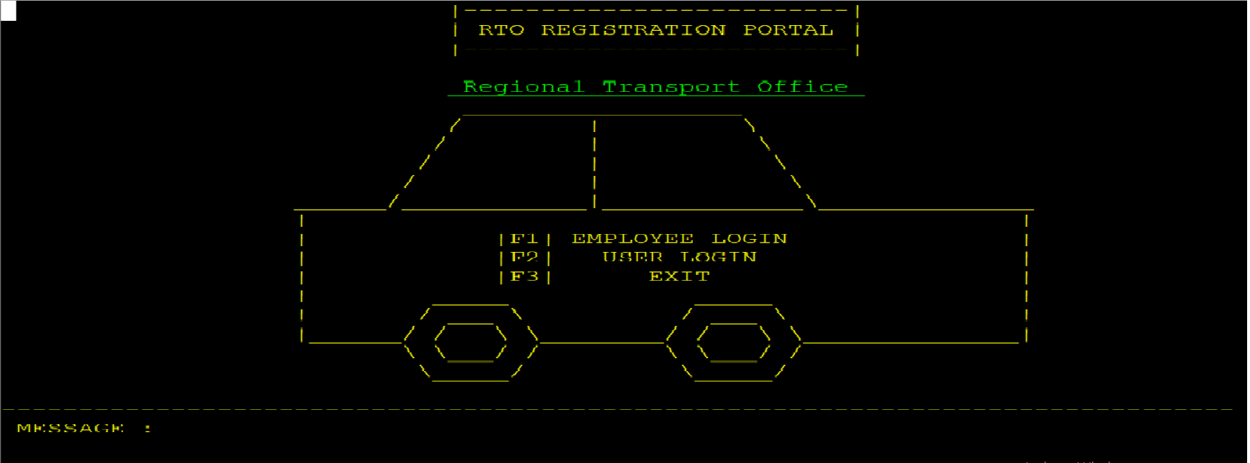
(1)

EMPLOYEE LOGIN:
When we press f1 key it displays next screen on that screen there is a employee login option where employee write their Emp-id and password and then press f1 key for login. If Employee write their correct credential, then Employee goes to the next screen otherwise it shows a message at bottom of screen (Invalid emp-id or a password). If we want back to the screen then press f11 key and for the home page press f12 key.

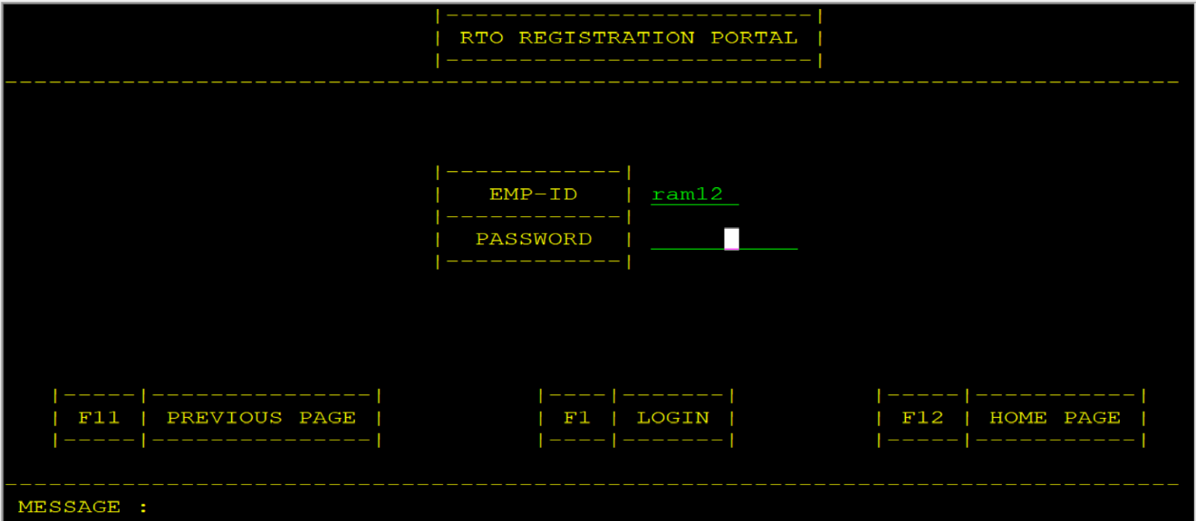

When we press f1 for login it displays next screen on that screen there is four option one for learning license records by pressing f1 key, second one for Permanent license records by pressing the f2 key, third for renew license records by pressing the f3 key, and last one for view/update license status by pressing the f4 key. If we want back to the screen then press f11 key and for log out press f12 key.

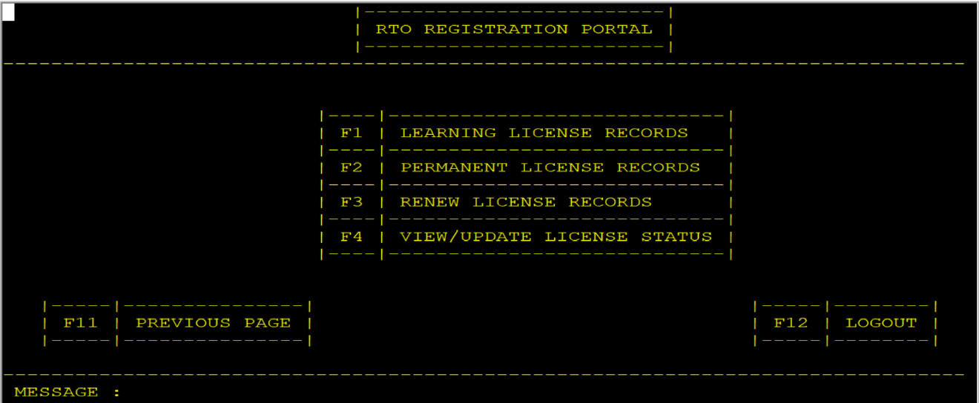
When we press f1 key for Learning license records it displays next screen on that screen there is User database records. If we want back to the screen then press f11 key and for logout press f12 key and for next page press f2 key.

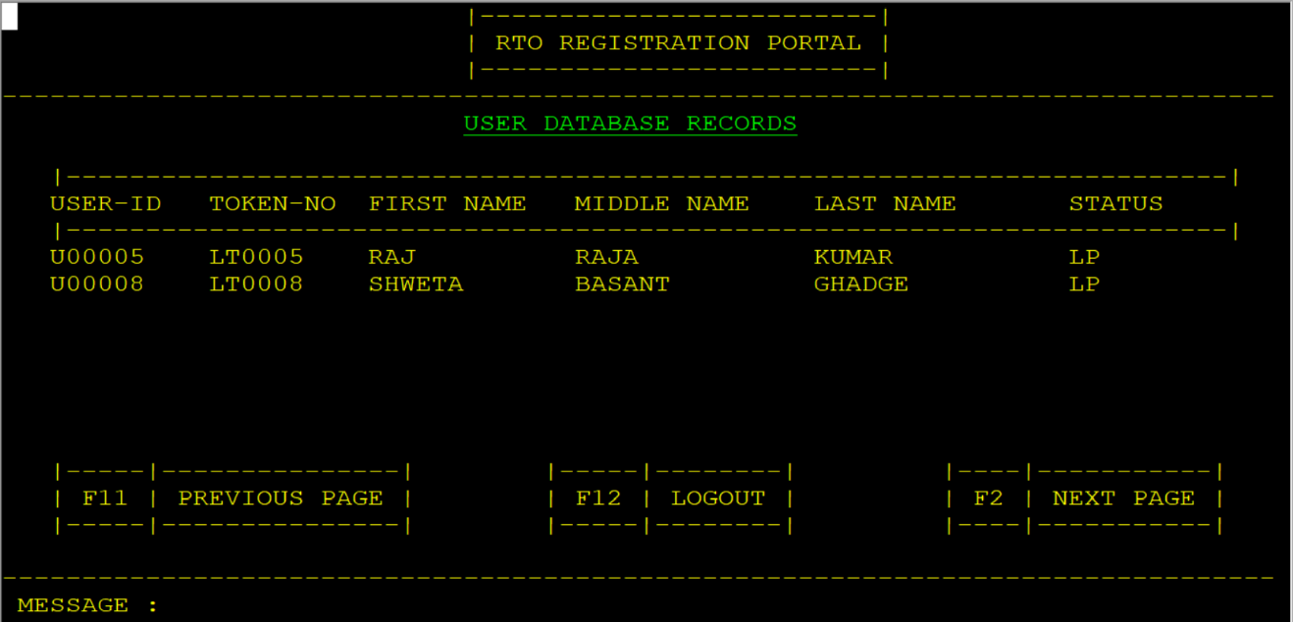

When we press f2 key for Permanent license records it displays next screen on that screen there is User database records. If we want back to the screen then press f11 key and for logout press f12 key and for next page press f2 key.

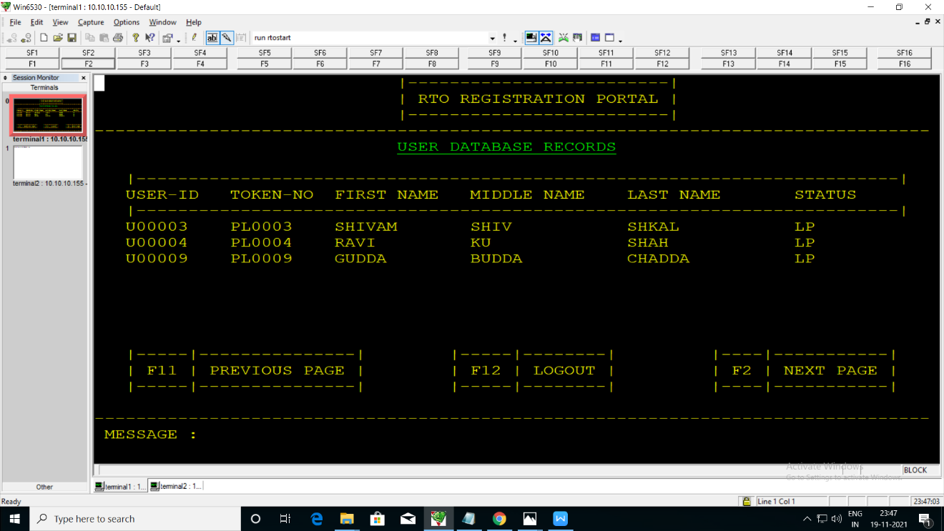
When we press f3 key for Renew license records it displays next screen on that screen there is User database records. If we want back to the screen then press f11 key and for logout press f12 key and for next page press f2 key.

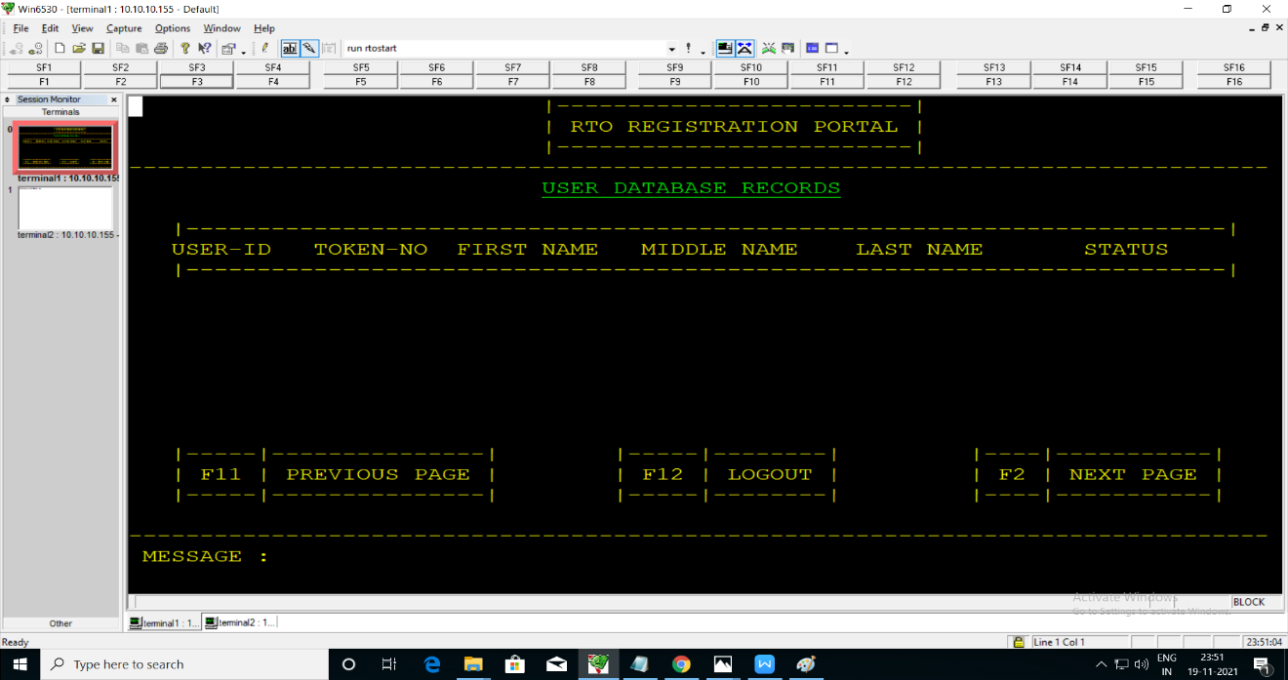

When we press f4 key for view/update license records it displays next screen on that screen there is User-id to update status. After filling correct user-id press f1 key for submit. If we want back to the screen then press f11 key and for logout press f12 key.

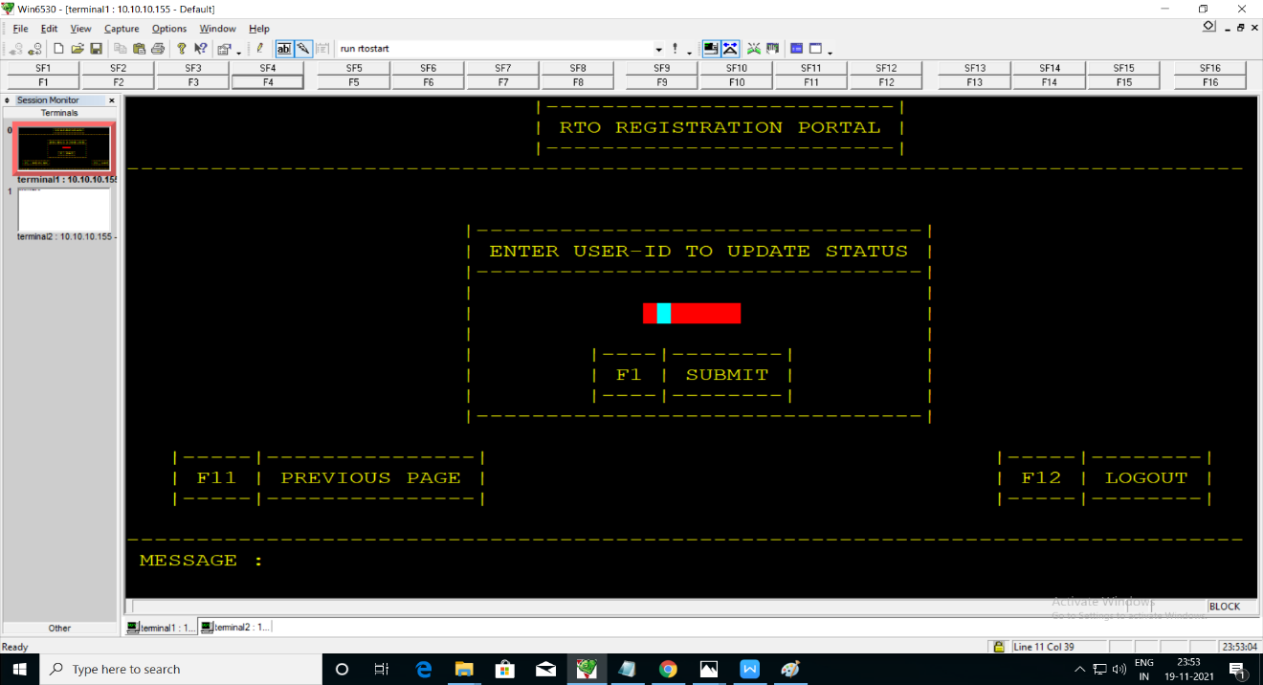
When we press f1 key for submit it displays next screen on that screen there is license approval screen. Employee have to update the license approved or license pending after that press f1 key for update. If we want back to the screen then press f11 key.
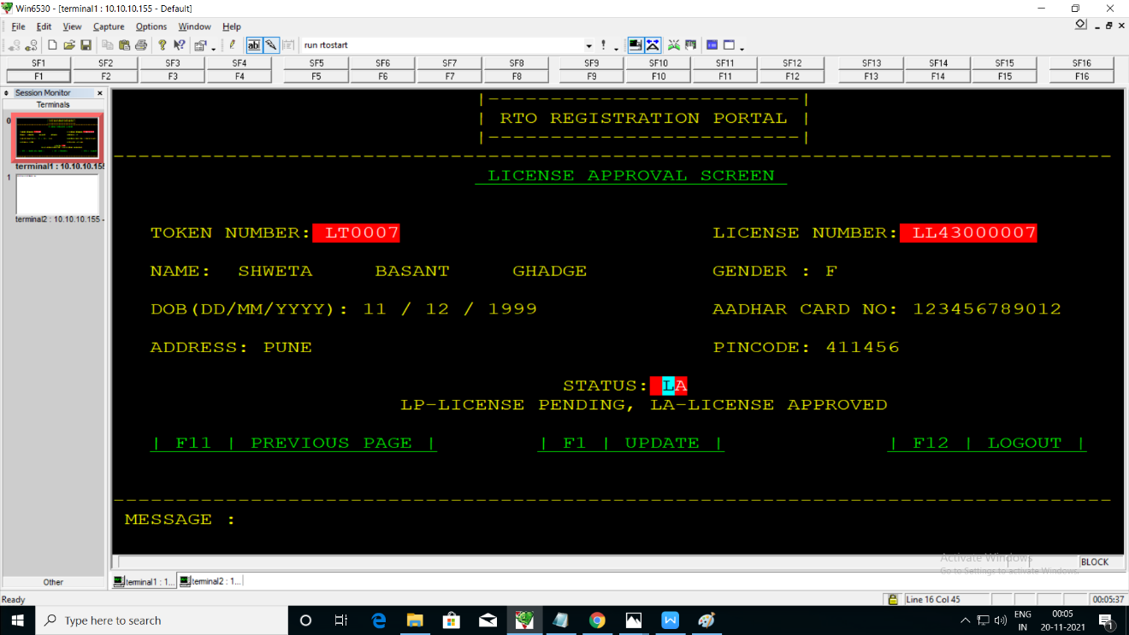

User login:
When we press f2 for User login it displays next screen on that screen there is three option f1 key for login, f2 key for forget password, f3 key for registration.
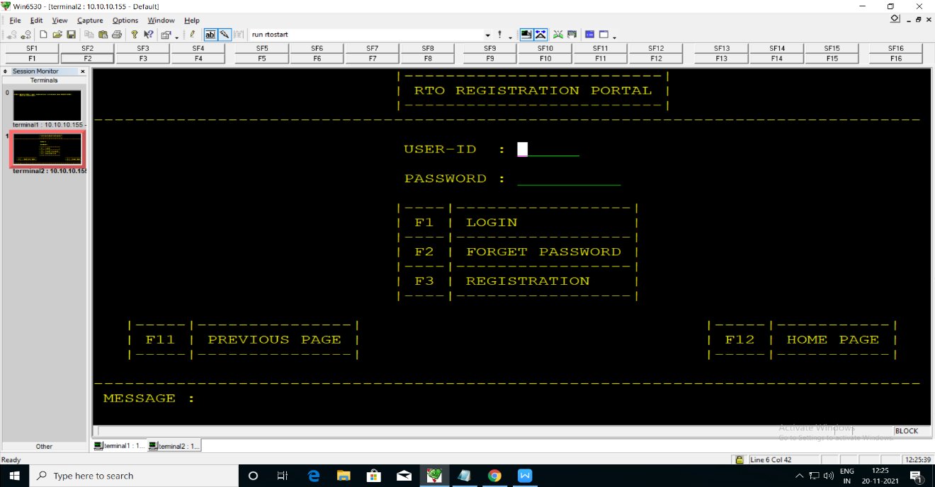
Newly user have to register first then login with their user-id and password.
For registration one can press f3 key then it displays next screen on that RTO registration form is there fill all the details and press f1 for submit. If we want back to the screen then press f11 key and for the home page press f12 key.

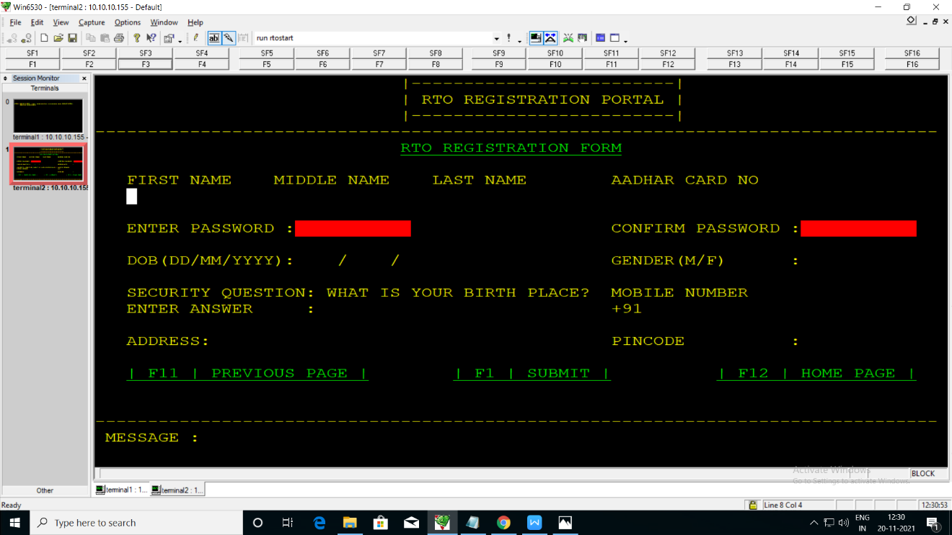

After pressing f1 key to submit the RTO registration form it displays the User-id and password. After that we press f1 key to continue the process it goes to the login page.

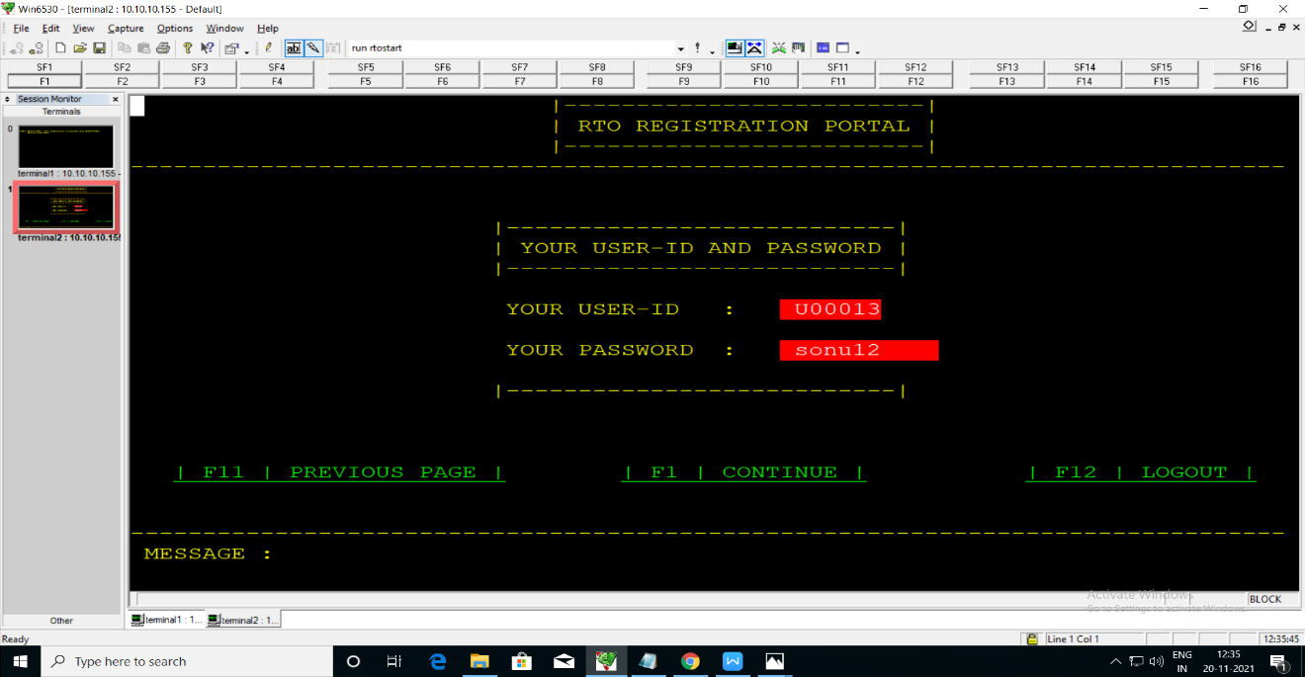
For login we have to write the user-id and password correct it displays next screen on that there is five option f1 for applying learning license, f2 key for applying permanent license, f3 key for applying renew license, f4 key for status check and f5 key for view license details. If we want back to the screen then press f11 key and for log out press f12 key.

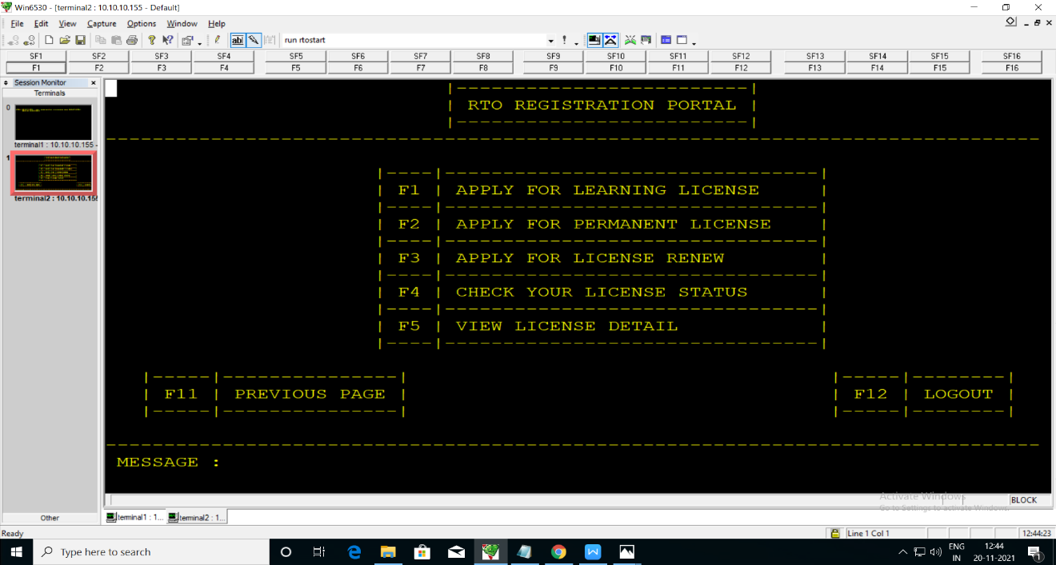

After applying for learning license it displays next screen on that there is two option one for 2 wheeler license and second one for 4 wheeler license. If we want back to the screen then press f11 key and for log out press f12 key.

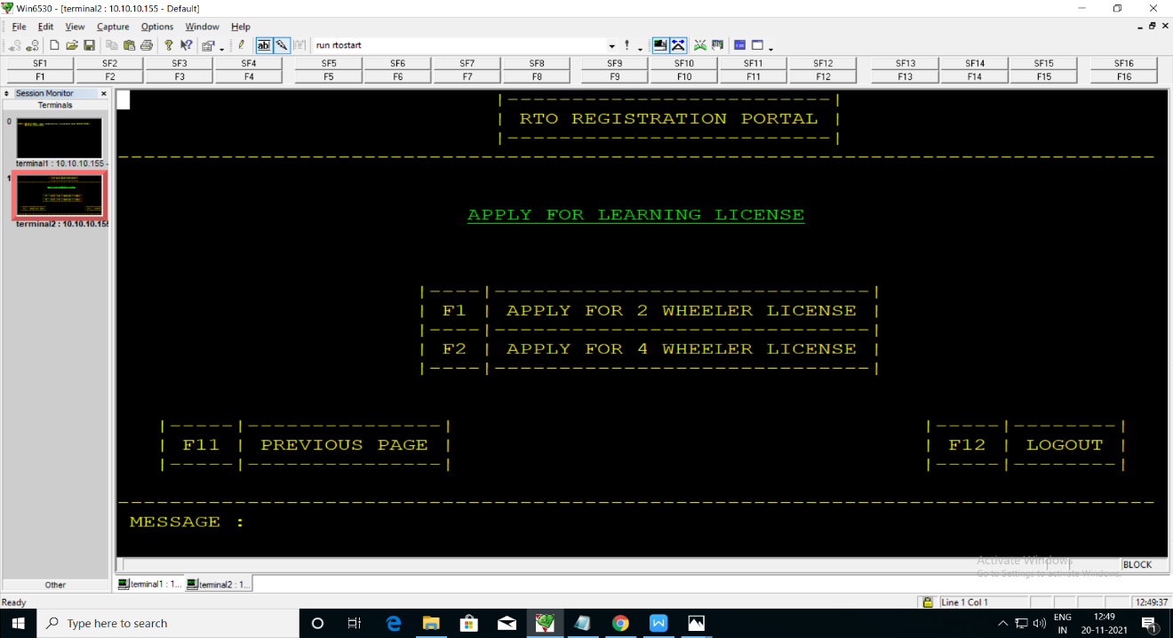
After pressing f1 key for applying 2 wheeler license it shows the next screen on that payment amount to be paid rs. 1000. Press f1 for submit and If we want back to the screen then press f11 key and for log out f12 key.

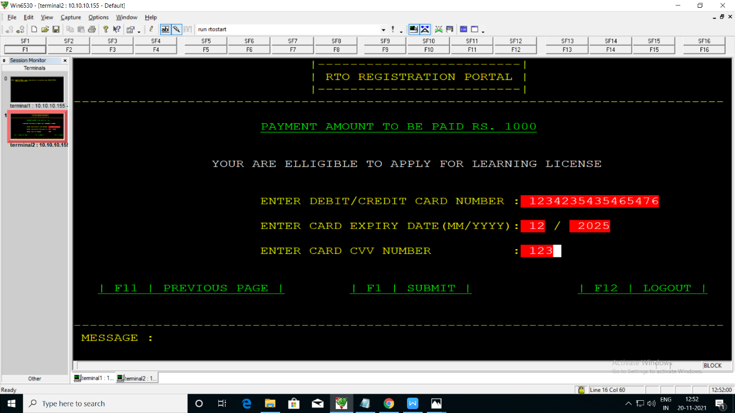

After pressing f1 key successfully applied for learning license in that we get token number. By pressing f1 key it exit and If we want back to the screen then press f11 key and for log out press f12 key.

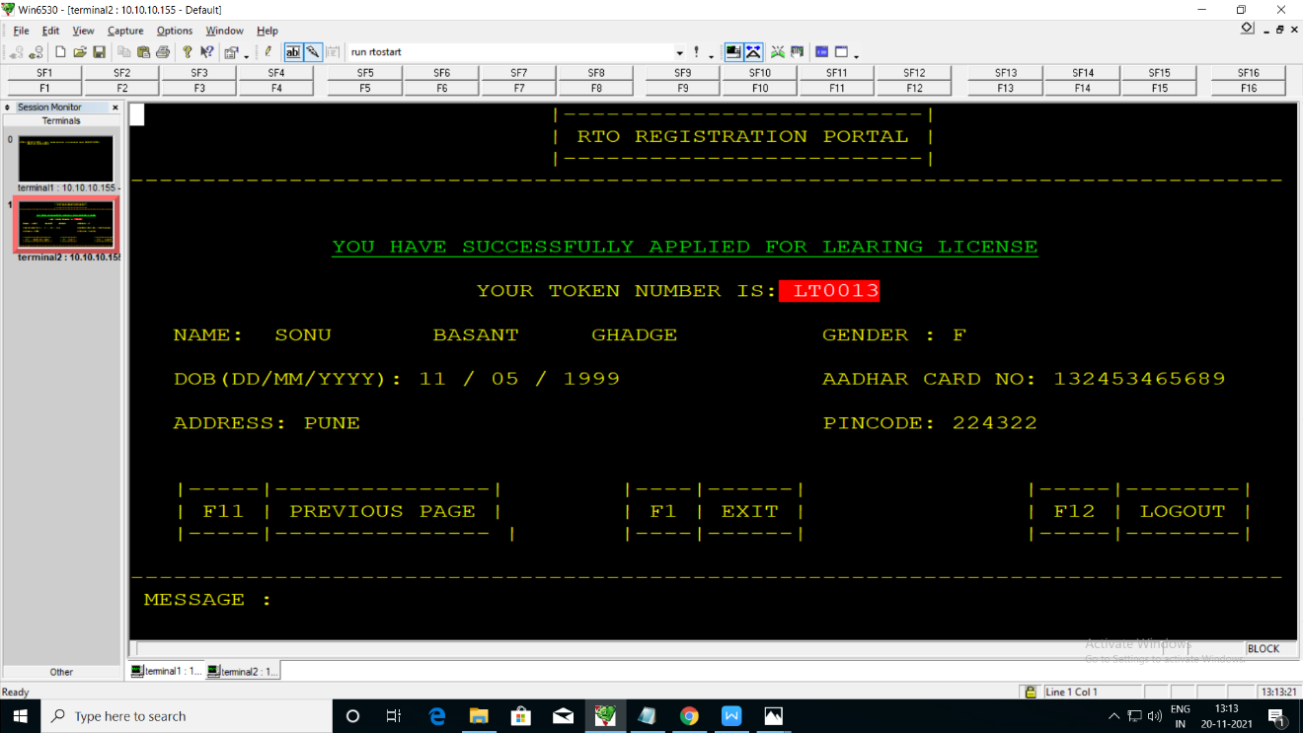
After pressing f2 key for applying permanent license it shows next screen in that we have to enter learning license number after that press f1 for submit. If we want back to the screen then press f11 key and for log out press f12 key.

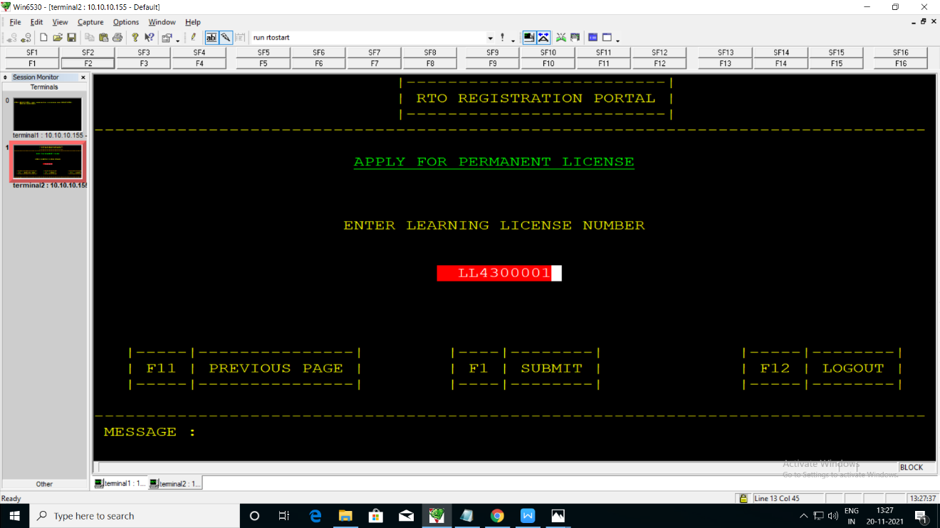

After submit it show successfully applied for permanent license. If we want back to the screen then press f11 key and for log out press f12 key.

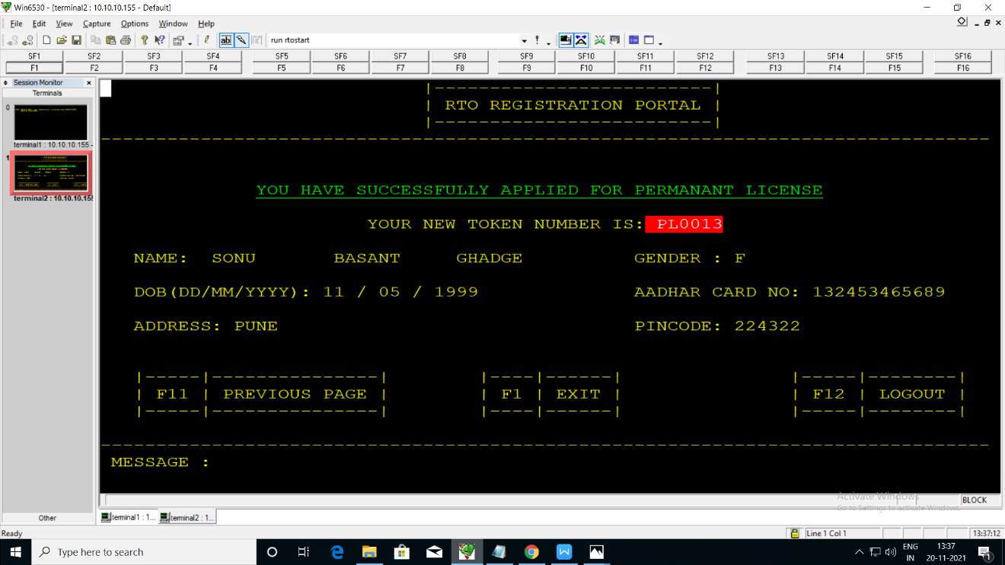
When press f3 key for renew license it displays next screen. If we want back to the screen then press f11 key and for log out press f12 key.

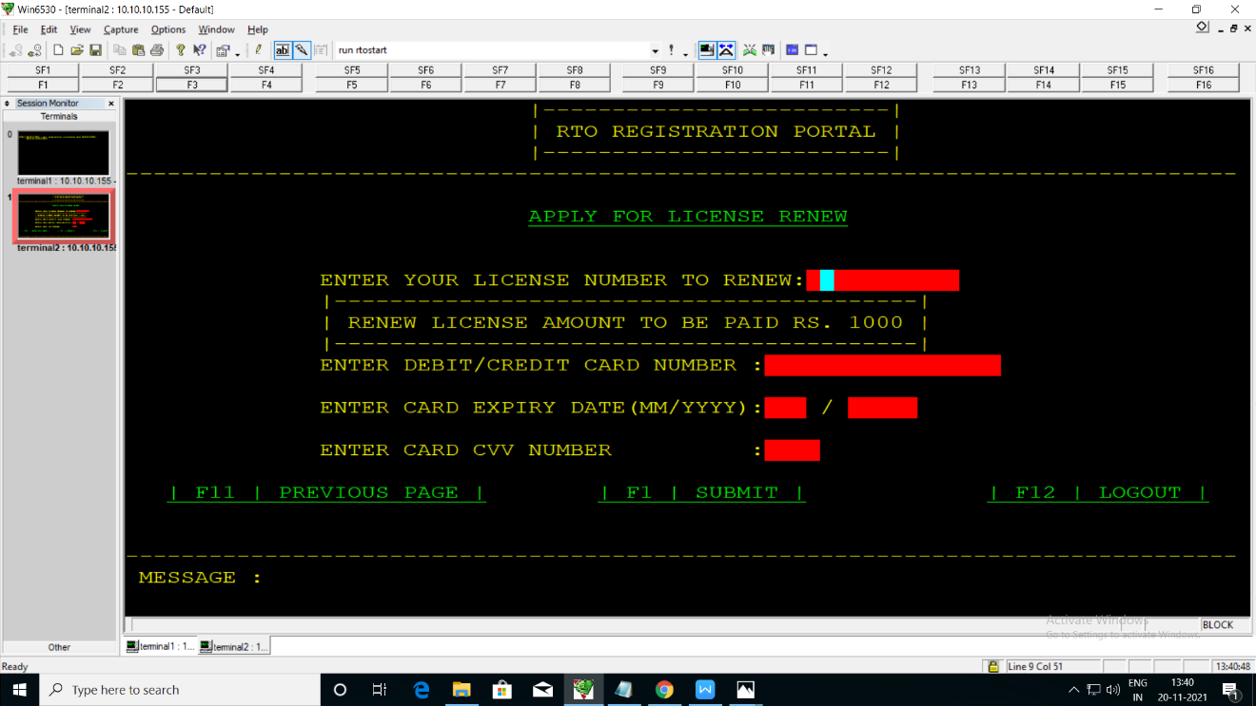

When press f4 key for Check license status enter token number then press f1 key for submit If we want back to the screen then press f11 key and for log out press f12 key.

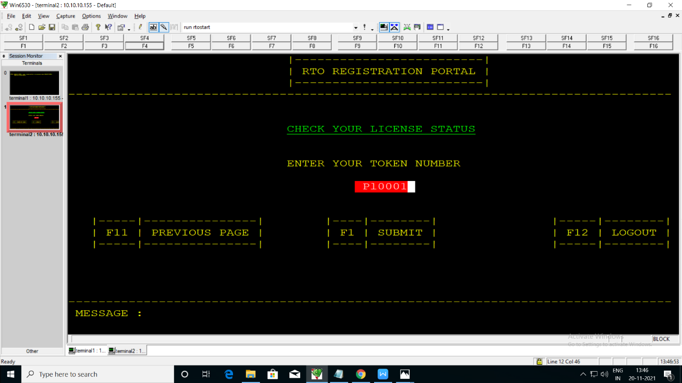
After pressing f1 key we get license number and status. F1 key for exit and
If we want back to the screen then press f11 key and for log out press f12 key.

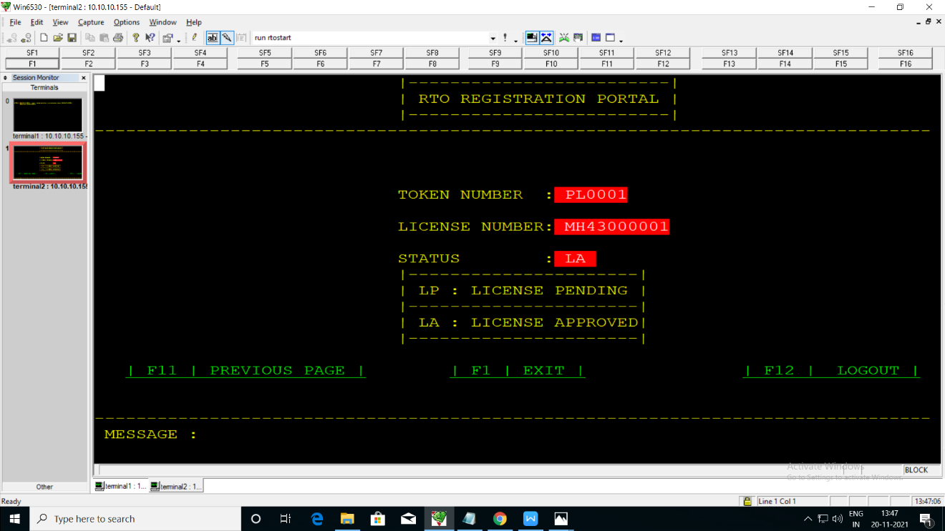

When we press f5 key for license details it show next screen on that we have to enter license number then press f1 to submit. F11 for back screen and f12 for log out.

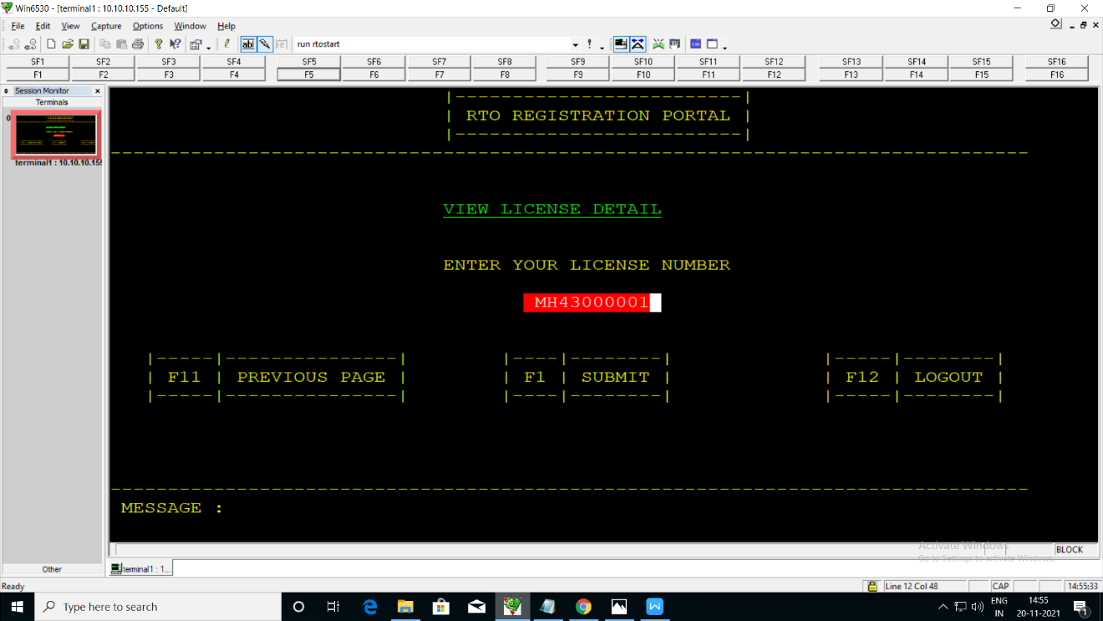
After pressing f1 key it shows all details of that user f1 key for exit and If we want back to the screen then press f11 key and for log out press f12 key.

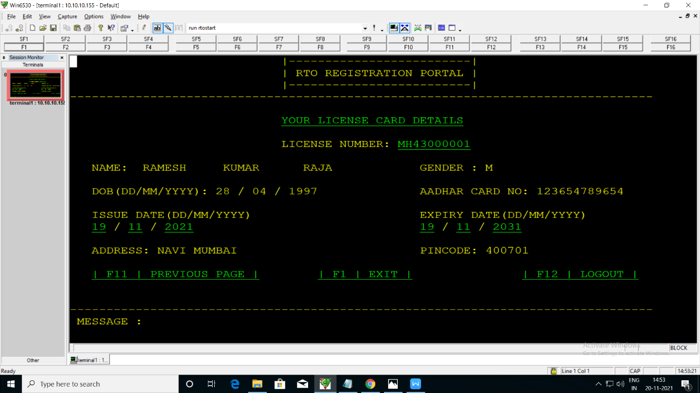

FORGET PASSWORD:
When we press f2 key for forget password it displays next screen on that we have to enter user-id and birth place then press f1 key to submit If we want back to the screen then press f11 key and for log out press f12 key.

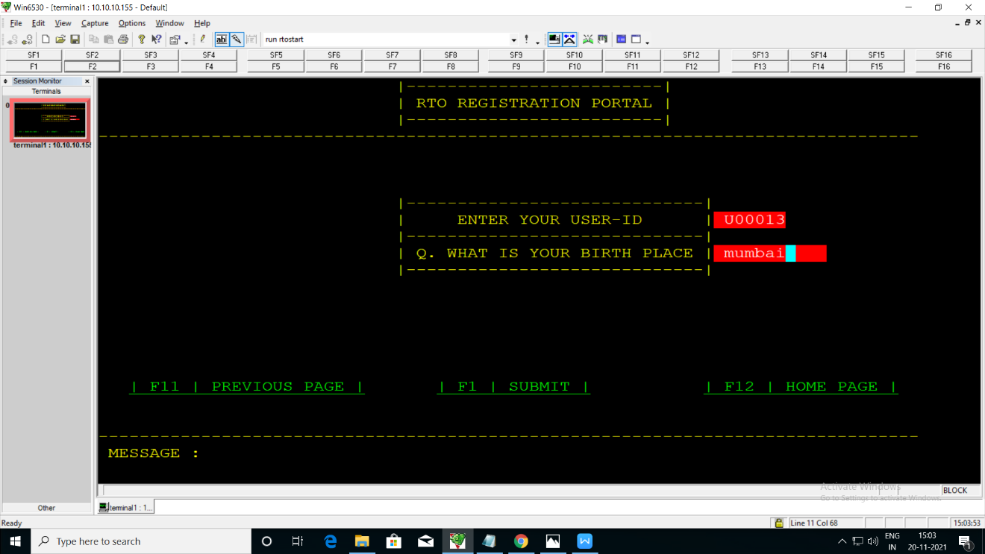

After pressing f1 key it shows the user-id and password.
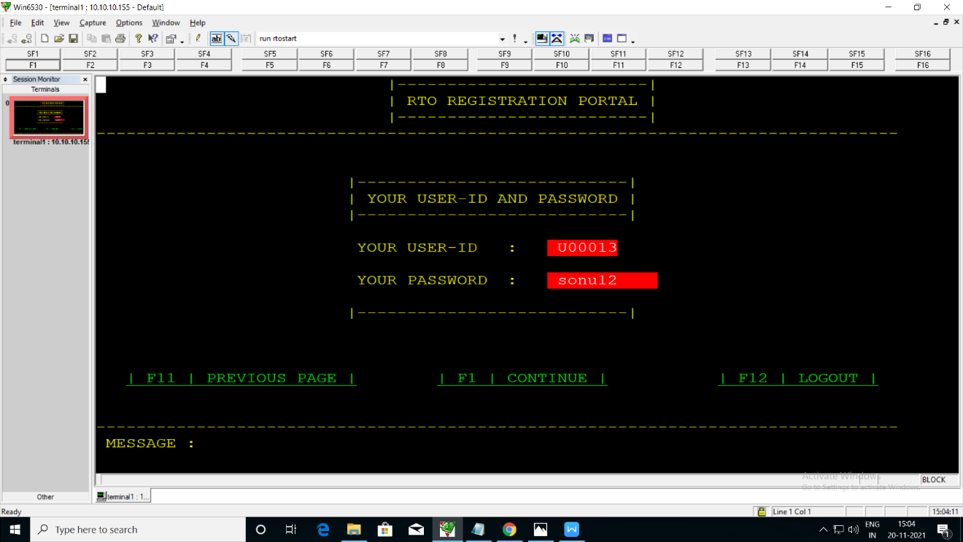

EXIT:
When we press f3 key it close the application.

6. Scobol validation

6.1 INSERT DATABASE:-

INSERT DATABASE | Positive  schema | Negative  schema
User-id | It must be alpha numeric. It accept Upper case characters. | It cannot take more than and less than 6 character. Also cannot take lower case characters and special characters.
Emp-id | It must be alpha numeric and accept special character. It accept Upper and Lower case characters. | It cannot take more than and less than 6 character
Password | It must be alpha numeric and accept special character, also Upper and lower case character | It cannot take more than 10 character
First Name | Only alpha character | It cannot take more than 10 character and also not take numeric and special character
Middle Name | Only alpha character | It cannot take more than 10 character and also not take numeric and special character
last Name | Only alpha character | It cannot take more than 10 character and also not take numeric and special character
Aadhar card | It takes only Numeric value | Not more than and less than 12 digit
Gender | It takes one character Upper and lower case character (Accept only M/F) | Not take numeric value and special character
Address | It takes only alpha character | It cannot take more than 35 character
Pincode | It takes only numeric value | Not take more than 06 digit and special character
Date of Birth(DD) | It takes only numeric value  Range in 01-31 | Not more than 02 digit and special character
Date of Birth(MM) | It takes only numeric value  Range in 01-12 | Not more than 02 digit and special character
Date of Birth(YYYY) | It takes only numeric value | Not more than 04 digit and special character
Mobile number | It takes numeric value | Not more than 10 digit and special character
Token Number | It must be alpha numeric. It accept Upper and Lower case characters. | Not more than 06 characters and special characters
Issue-Date | It takes only numeric value  Range in 01-31 | Not take more than 02 digit and special character
Issue-Month | It takes only numeric value  Range in 01-12 | Not take more than 02 digit and special character
Issue-Year | It takes only numeric value | Not take more than 04 digit and special character
Expire-Date | It takes only numeric value  Range in 01-31 | Not take more than 02 digit and special character
Expire-month | It takes only numeric value  Range in 01-12 | Not take more than 02 digit and special character
Expire-year | It takes only numeric value | Not take more than 04 digit and special character
Card-number | It takes numeric value | Not more than 16 digit and special character
License Number | It takes alpha numeric value | Not more than 10 digit and special character

6.2 VIEW DATABASE:-

VIEW  DATABASE | Positive  schema | Negative  schema
User-id | Valid user-id must be entered | Invalid user-id
Emp-id | Valid emp-id must be entered | Invalid emp-id
Password | Valid password must be entered | Invalid password
Token number | Valid Token number must be entered | Invalid token number
License number | Valid license number must be entered | Invalid license number

  - UPDATE DATABASE :-

UPDATE DATABASE | Positive  schema | Negative  schema
Emp-id | Valid emp-id must be entered so update the data is successful | Invalid emp-id cannot update the data
Password | Valid password must be entered | Invalid password
User-id  (only user-id) | Valid user-id must be entered so update the data is successful | Invalid user-id cannot update the data

7. TAL SERVER VALIDATION STEPS:

A) INSERT DATABASE :

a. User Id -
- Enter user id using TAL Server it must be alphanumeric and maximum 6 characters.
- It accepts lowercase or uppercase character.
- If you enter any symbol, special character or greater than 6 characters it’s getting wrong Input on display.

b. Emp Id -
- Enter Emp id using TAL Server it must be alphanumeric and maximum 6 characters.
- It accepts lowercase or uppercase character.
- If you enter any symbol, special character or greater than 6 characters it’s getting wrong Input on display.

c. Password –
- Using TAL server enter your password combination of lowercase, uppercase alphanumeric and special character.
- Password must contain minimum 10 characters.
- If you enter lower than 10 characters you will get error wrong password or enter password greater than or equal to 10 characters.
- If you enter all uppercase, all lowercase or special character it’s also showing error.

d. First Name / Middle Name / Last Name -
- Using TAL server entered first/Middle/last name only alpha character and maximum length is 10 characters.
- It can't take any numeric and special character.
- If you enter any numeric or special symbol it showing error "you enter wrong input".

e. Aadhar Card –
- Using TAL server enter adhar number only in 12 digit numeric number.
- If you entered lower than 12 digits it getting error.
- If you entered rather than numeric number, it also getting error.

f. Gender -
- Using TAL server enter your gender as "M" for male and "F" for female.
- You can use lower or uppercase character but you can't use any other character or special character.
- If you enter any other character, number or any special character it showing error.
g. Address -
- Address takes alphanumeric and maximum 35 characters.
- Address doesn't take more than 35 characters.

h. Pin code -
- Using TAL server enter only 6 digit numeric number.
- It can't take lower than 6 and more than 6 numeric numbers.
- It can't take any other character or special character.

i. Date of Birth (DD) / Issue-Date / Expire-Date -
- Using TAL server enter your date of birth/issue-date/expire date 2 digit numeric value range between 01-31.
- If you entered other than 01-31 it getting error.

j. Date of Birth (MM) / Issue-Month / Expire-Month -
- Enter only 2 digit numeric value range between 01-12.
- If you entered more than 2 digits or other than 01-12 it’s getting error.

k. Date of Birth (YYYY) / Issue-Year / Expire-Year -
- Enter only 4 digit numeric value.
- You can't take more or lower than 4 digit numeric value also it can't take any special character.

l. Mobile Number –
- Using TAL server enter your mobile number only 10 digit numeric value.
- You can enter without +91 and you cannot use more than 10 and lower than 10 numeric numbers.

m. Token Number –
- Using TAL server enter 6 digit numeric values for token number.
- It only uses 6 digit numeric values.

n. Card-Number / License Number -
- Using TAL server enter only 16 digit numeric number.
- You can't enter special character.
- You can't enter lower than 16 and more than 16 numeric number.

B) VIEW DATABASE :

a. User Id and Password --
- Using TAL server if you want to view data using user id and password then enter valid user id and password.
- If you entered invalid or wrong user id and password then error message show on display "Invalid User Id or password".
- If you entered valid user id and password then showing all information related user id in database.

b. Emp- ID and Password -
- Using TAL server if you want to view data using employee- id and password then enter valid employee id and password .
- If you entered invalid or wrong employee id and password then error message show on display "Invalid Employee Id or password".
- If you entered valid Employee Id and password then showing all information related Employee Id in database.

c. License number -
- Using TAL server if you want to view data using License number then enter valid License number.
- If you entered invalid or wrong License number then error message show on display "Invalid License number ".
- If you entered valid License number then showing all information related License number in database.

d. Token Number -
- Using TAL server if you want to view data using token number then enter valid token number.
- If you entered invalid or wrong token number then its showing "Invalid Token Number" error on display.
- If you entered correct token number then showing all information about this token number.

C) UPDATE DATABASE :

a. Emp- ID and Password -
- Using TAL server enter employee id and password for update related information about employee id.
- If you entered valid employee id and password then showing database option for update database.
- If you entered wrong employee id and password then showing "Invalid employee id or password"

b. User-id (only user-id) -
- Using TAL server enter valid user-id update related information about user-id.
- If you entered valid user-id then showing database option for update.
- If you entered wrong or invalid user-id then showing "Invalid user-id " error on display.

8. DDL Database

6.1 User login details:
Name | Description | Data Type | Size | Constraints
User-id | Id of User | Alpha-numeric | 06 | Primary key
Password | Password | Alpha-numeric | 10

6.2 User registration details:
Name | Description | Data Type | Size | Constraints
User-id | Id of User | Alpha-numeric | 06 | Primary key
Password | Password | Alpha-numeric | 10
FName | First name | Alpha-numeric | 10
M Name | Middle name | Alpha-numeric | 10
L Name | Last name | Alpha-numeric | 10
Aadhar | Aadhar number | Alpha-numeric | 12 | Alternate key
Gender | Gender | Alpha-numeric | 01
Addrs | Address | Alpha-numeric | 35
Pincode | Pincode | Alpha-numeric | 06
DOB(dd) | Date of Birth(date) | Alpha-numeric | 02
DOB(mm) | Date of Birth(month) | Alpha-numeric | 02
DOB(yy) | Date of Birth(year) | Alpha-numeric | 04
Mob-No | Mobile number | Alpha-numeric | 10

6.3 Applied license details:
Name | Description | Data Type | Size | Constraints
Tok-No | Token Number | Alpha-numeric | 06 | Primary key
User-id | Id of user | Alpha-numeric | 10 | Alternate key
FName | First name | Alpha-numeric | 10
M Name | Middle name | Alpha-numeric | 10
L Name | Last name | Alpha-numeric | 10
Gender | Gender | Alpha-numeric | 01
DOB(dd) | Date of Birth(date) | Alpha-numeric | 02
DOB(mm) | Date of Birth(month) | Alpha-numeric | 02
DOB(yy) | Date of Birth(year) | Alpha-numeric | 04
Aadhar1 | Aadhar number | Alpha-numeric | 12 | Alternate key
Addr | Address | Alpha-numeric | 20
Pin-Code | Pin-code | Alpha-numeric | 06
Iss-Dt | Issue-date | Alpha-numeric | 02
Iss-mth | Issue-month | Alpha-numeric | 02
Iss-yy | Issue-year | Alpha-numeric | 04
Exp-Dt | Expire-date | Alpha-numeric | 02
Exp-mth | Expire-month | Alpha-numeric | 02
Exp-yy | Expire-year | Alpha-numeric | 04
Card-no | Card number | Alpha-numeric | 16
Lic-no | License number | Alpha-numeric | 16 | Alternate key

